**Portfolio Project – Website Specification Document**

**Abstract**

This website specification document describes the content and design of my CIS 241 Web Dev I Final Project – Creating a Personal Website Project Portfolio. The project consists of six total working documents, with five HTML5 text files and one CCS3 style sheet, and is designed to demonstrate competence of the material taught in the CIS 241 Web Development I course.

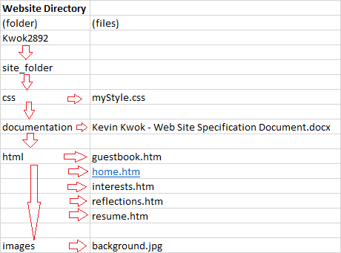

**Purpose of Documents**

This section describes the common elements contained in each page, as well as their purpose in the overall website.

Note: * This page can only be navigated to only if the user clicks the respective button, present in the <header> of each webpage document.

1. Homepage (home.htm) – This is the main page of my portfolio project, and serves as the landing page for any users visiting the website. Additionally, this landing page uses paragraphs to provide a brief introduction to the website developer’s profile and interests.
2. Resume (resume.htm*) – This document presents the web developer’s current resume as a table, which consists of a job description and duties they aspire to have as their next job (before or upon completion of their certificate), their current skillset, their list of educational institutes attended, and their most recent employment history.
3. Guestbook (guestbook.htm*) – This document presents a web form to the user, and welcomes them to enter their name, indicate how they discovered this website, add their personal website for the author to visit, and a text-area for comments to the author.
4. Interests (interests.htm*) – This document contains a list of hyperlinks leading to external websites that are relevant to the web developer’s interests. Each hyperlink have a title attribute to describe the website they will be redirected towards.
5. Reflections (reflection.htm*) – This document contains a list of strings that describe the web developer’s thoughts and reflections on the content learned from the past academic quarter.
6. CSS3 (myStyle.css) – This document is responsible for several styling elements that define the layout of the overall website, as well as elements that are specific to each webpage.

**Features**

1. Common elements: Each document, sans myStyle.css, are defined with a <!DOCTYPE html> declaration, metatags (author, keywords, description, http-equiv, and robots), and one <html>, <head> and <body> element. There is a <header> and <footer> tag contained in each and every webpage. The <header> contains the site’s heading, interactive buttons that serve as redirect buttons for separate pages within the site. The <footer> contains a copyright symbol, as well as an <a> tag tied to the author’s email, so any users visiting the website may send an email to them.
2. Homepage (home.htm) – This document is the landing page for the website, and contains two <div> tags, an <h2> tag, and three <p> tags. The <div> tags are used to stylize the webpage.
3. Resume (resume.htm*) – This document contains two <div> tags, an <h2> tag, a <table> tag, two <tr> tags, four <th> and <td> tags, and several <ul> and <li> tags. The <div> tags are used to stylize the webpage.
4. Guestbook (guestbook.htm*) – This document contains one <div> tag, an <h2> tag, one <form> tag, two <input> tags, one <select> tag, and one <textarea> tag.
5. Interests (interests.htm*) – This document contains two <div> tags, an <h2> tag, a <ul> tag, four <li> tags, and four <a> tags. Clicking <a> tag will open up a new window/tab in the user’s web browser. The <div> tags are used to stylize the webpage.
6. Reflections (reflection.htm*) – This document contains two <div> tags, an <h2> tag, one <ul> tag, and three <li> tags. The <div> tags are used to stylize the webpage.
7. CSS3 (myStyle.css) – This document, which is the primary visually and styling component for the entire website, contains several selectors and properties. The main defining feature of this document is the background image, which is contained in the (../images/) folder within the website’s site_folder directory, and presents several colors that are on the cooler side of the RGB spectrum. The warm color palette choices of the common elements, including the headers, buttons, and content fields, were selected to contrast against the background image. The text readability throughout the website is enhanced with a semi-transparent RGBA layer, allowing the user to not only appreciate the background, but also the visual contrast.